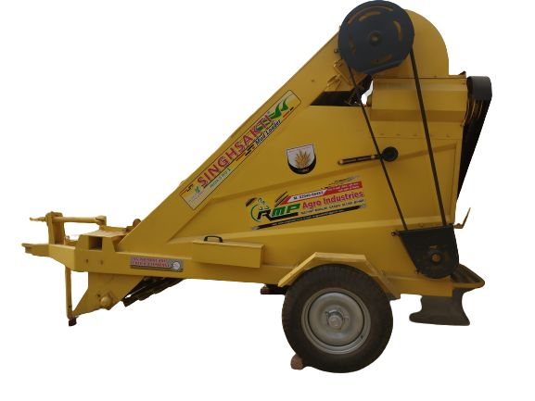 **MUD LOADER**

Landforce mud loader that is manufactured using best quality raw material. These have sturdy design that enables us to effectively satisfy the needs of our customers. These are designed and developed with the help of latest technology and innovations.

**Features:-**

* One Trolley Filling Capacity 1 minute.
* Durability
* Precise designing